Example of writing section materials (in English):
ECONOMIC SCIENCES
ATANASIEV Oleg,
Ph. D. (History), Associate Professor,
Kharkiv National University
ORCID ID: 0000-0000-0000-0000 (якщо є)
FLAKО Viktor,
D. Sc. (History), Professor,
Kharkiv National University
ORCID ID: 0000-0000-0000-0000 (якщо є)
Ukraine
ECONOMIC TRENDS OF THE MODERN PUBLISHING INDUSTRY
Publishing in any country is an objective component and an inherent part of its functioning. No exception Ukraine, which is experiencing a period of formation of a democratic political culture and radical economic transformation. These processes affect the evolution of national publishing, which corresponds to the paradigm of political and power relations, political system, society and parade tasks that it implements. Transition to modern information system and a new system of social relations is complex and controversial. Not so easy to abandon ideological accretions recent past and keep their basic principles in the struggle for the creation of a new democratic political culture.
They do not exclude the possibility of the inclusion in plans of the publication of literature for this category of society, however only under appropriate conditions. As it is seen in the Table 1, these conditions are practically identical in publishing houses with an experience in the studied field and without it.
Table 1. Publishers motives for inclusive literature
Source: Author’s research.
No. | Publishers | Library  Demand | State  Support | Grant  Program | The presence of an interesting  author manuscript
1 | With an experience | 44% | 78% | 67% | 33%
2 | Without an experience | 40% | 60% | 52% | 40%

The main reasons for the absence of inclusive literature in the portfolio of publishers is shown in fig. 1.
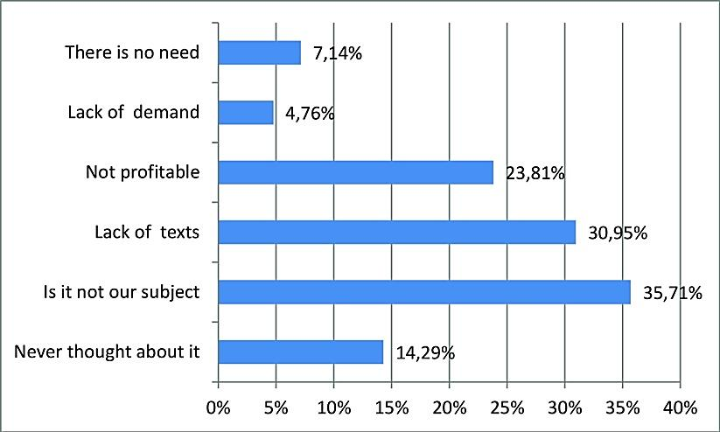
Figure 1. Percentage of the inclusive literature in the portfolio of
publishers and corresponding reasons
The study enabled to understand that until 2020 the systematic professional researches on the topic of inclusion in the portfolio of the Ukrainian publishing houses has not been conducted.
These results showed some confusion and unsystematic approach of the professional publishing community to issues of the inclusion, proved feasibility of further development of the inclusive literature as an effective innovative marketing resource, resource, aimed at publishing contemporary works about persons with disabilities, personal diversity and use of available book formats.

The Dolly Gray Children’s Literature Award. Information and Procedures. Retrieved from https://www.dollygrayaward.com
Meijer, Cor. J. W., & Watkins, A. (vol. eds.) (2016). Implementing Inclusive Education: Issues in Bridging the Policy-Practice Gap. In Forlin, C. (series ed.) International Perspectives on Inclusive Education, 8. UK, Emerald Publishing Limited.
Kirkpatrick, В. (2018). Disability, cultural accessibility, and the radio archive. New Review of Film and Television Studies, 4(16), 473–480. Retrieved from https://doi.org/10.1080/-17400309.2018.1524963

